

Swami: The Next Generation Biology Workbench
Draft version, has not been fully proofed.

WORKBENCH TOOLS
(Creating XML Description for new Tool)

Subject
This document describes how we create an XML representation (based on Pise DTD) for integrating a new tool.
Change History

Author | Date | Version | Comments
Rami Rifaieh | 04/01/08 | V 1.0 | Creation
mamiller | 04/22/08 | V 1.1 | Editing and Expanding; draft

Contents
1 Introduction 5
2 Pise XML Description: 6
2.1 Header and descriptor 6
2.2 Basic Attributes 6
2.2.1 The command attribute 6
2.2.2 How to use and configure parameters 7
2.2.2.1 Parameters are organized by grouping and by paragraphs 7
2.2.2.2 Defining Parameters 7
2.2.2.3 Allowed values for Parameter “Type” 9
2.2.2.4 Allowed values for Parameter attributes 10
2.3 Attributes containing code: 13

Introduction
Creating new tools to be integrated within Swami requires understanding the underlying XML representation. For the current implementation of Swami, we use Pise XML and its DTD as the framework for deploying tools.

We have tried to keep the DTD of Pise as standard for Swami Tools. However, we have made a few changes. We added the parameter isinput=1 to indicate that the parameter in question is the main input of the tool. See Pise Code Generation under SVN for more description and the architecture of the use of Pise within Swami.

We describe here the different elements and attributes of the Pise DTD and its use within the Swami, we have started this document form the basic description of these elements form Pise and noted our use and description in RED.
Pick PCR primer(s)? 
Each XML document for tool should start with:

<?xml version="1.0" encoding="ISO-8859-1" ?>
<!DOCTYPE pise SYSTEM "http://www.phylo.org/dev/rami/PARSER/pise.dtd">

<pise>
...
<!—- To include all the elements-->
...
</pise>

If a DB is needed, the address is put in after

<!DOCTYPE pise SYSTEM "http://www.phylo.org/dev/rami/PARSER/pise.dtd">
And before </pise>

An example of the addresses are here:

[<!ENTITY nucdbs SYSTEM "http://www.phylo.org/dev/rami/XMLDIR/nucdbs.xml">
<!ENTITY protdbs SYSTEM "http://www.phylo.org/dev/rami/XMLDIR/protdbs.xml">
<!ENTITY blastDBpath SYSTEM "http://www.phylo.org/dev/rami/XMLDIR/blastDBpath.xml">
<!ENTITY fastaDBpath SYSTEM "http://www.phylo.org/dev/rami/XMLDIR/fastaDBpath.xml">
<!ENTITY blocksDBpath SYSTEM "http://www.phylo.org/dev/rami/XMLDIR/blocksDBpath.xml">
<!ENTITY nucDBfasta SYSTEM "http://www.phylo.org/dev/rami/XMLDIR/nucDBfasta.xml">
<!ENTITY protDBfasta SYSTEM "http://www.phylo.org/dev/rami/XMLDIR/protDBfasta.xml">]>

These addresses lead to small auxiliary XML files that point in turn to DBs.

Pise XML Description:

Header and descriptor

<head>
<title>Blast</title>
<description>BLAST (Basic Local Alignment Search Tool) </description>
<version>… </version>
</head>

<title> is a string. Gives a short title for the tool.
<version> is self explanatory.

The string for title, and the string for version are combined to create a hyperlink in the tool selection page. Clicking this hyperlink set the tool to a task.

<description> is a short description that is also published on the tool selection page.

Basic Attributes

These are modifier tags that help construct the command line without code

The command attribute
<command>blast2</command>

<command> Is used as the unique identifier for artifacts that belong to this program. This means that the files containing this program descriptions will be named with this string. For example: clustalw.html, clustalw.pl, etc. and that (in PISE) the effective Unix command will start by the string: "clustalw".

In Swami, code generation (JSP, Java, etc.) requires that the name of the file “XYZ.xml” is identical to the value given in <command>:

<command>XYZ</command> = XYZ.xml

You can also define <command> as a parameter. (see below)

In Pise: default <group> for command type parameter : 0 (see below)

In Swami, <command> is not associated with a group, since it is not used to construct the Unix command line.

How to use and configure parameters

Once the command tag is given, the parameters of the file are defined. As some programs have many parameters, there are two levels of organization for parameters.

Parameters are organized by grouping and by paragraphs
Multiple lists of parameters are encased in the <parameters></parameters> tag. There can be multiple <parameters> tags throughout the file.
It's convenient to group these into appropriate rubrics. The Paragraph attribute describes the grouping, and also is used to organize the output and explanatory notes included as comments for display purposes. The grouped variables are listed within the vlist attribute:
<parameters>
<paragraph>
<name>fastpw</name>
<prompt>Fast Pairwise Alignments parameters</prompt>
<precond>
<language>perl</language>
<code>($quicktree eq "fast")</code>
</precond>
<group>2</group>
<comment>
<value>These similarity scores calculation</value>
</comment>
<vlist>
<value>1</value>
<label>1:Standard</label>
etc….
</vlist>
</paragraph>
</parameters>

The order of this list is significant, because it determines the order of the group in the HTML form produced. Text from all comments included in a paragraph are rendered under a heading for the paragraph, and displayed as a help feature at the bottom of the page. The order of the items in the help page is also determined by the order of the paragraphs.

Defining Parameters
There is one definition for every "parameter" of the command. Each Parameter has a name and a type that describe its general behavior and properties. A parameter has one name, and one or many attributes. A parameter definition is composed of a list of attributes, defining the prompted text, the default value, etc... Here is the definition:

<!ELEMENT parameter (paragraph|(name, attributes)+)>
<!ATTLIST parameter type (InFile|Sequence|OutFile|Results|Switch|Excl|List|Integer|Float|String|Paragraph|Label) #REQUIRED

ismandatory %boolean; #IMPLIED
iscommand %boolean; #IMPLIED
ishidden %boolean; #IMPLIED
issimple %boolean; #IMPLIED
isclean %boolean; #IMPLIED
isstandout %boolean; #IMPLIED>

Red are not relevant in SWAMI.

Example 1. Single Parameter

<parameter issimple=”1” type="Paragraph">
<paragraph>
<name>filter_opt</name>
<prompt>Filtering and masking options</prompt>
<group>4</group>
<comment>
<value>Blah blah blah.</value>
</comment>
</parameter>

In this example, the first statement type="Paragraph"> defines the <parameter> as a paragraph. The statement issimple=”1” specifies that it will be included on the simple form as well as the advanced form. Allowed values for type and

The <paragraph> tag then opens the definition of the attributes of that paragraph.

<name> identifies the parameter name. The parameter name can be used to specify and manipulate a parameter. For example, if the parameter is meant to actually manipulate data as in the case:

<parameter issimple=”1” type="integer">
<name>alignment</name>

the parameter name is used to code conditions in other parameters by referring to it as $alignment.

<prompt> provides the text that will appear as a header for the paragraph, and as a header above any comments included in the paragraph definition. These will be posted at the bottom of the page. The heading specified by <prompt> is displayed in the form and the help section, and these are hyperlinked to each other.
<group> the value entered here specifies the order of this parameter in the command line.

In PISE: group values are unbounded, some values are 9999, 999, etc.
In SWAMI: group values between -99 to 99 are allowed. We prefer to use
also the absolute position for the parameter in the UNIX command and not
the relative position as in PISE. (N.B: if | group value | > 99
PiseCommandRenderer will fail)

<comment> indicates that a text string that will be provided to be placed at the bottom of the form.
<value> the actual text displayed in the comment

Example 2. Single Parameter with several attributes:

<parameter type="Switch">
<name>filter</name>
<attributes>
<prompt>Filter query sequence (DUST with blastn, SEG with others) (-F)</prompt>
<format>
<language>perl</language>
<code>($value) ? "" : " -F F"</code>
</format>
<vdef><value>1</value></vdef>
<group>4</group>
</attributes>

<attributes> This tag is used when many attributes are specified for a single parameter. The tag encloses the complete list of attributes for a parameter.

Allowed values for Parameter “Type”

Allowed values are as follows:

'InFile' | Swami: Input file, used for sequences and non-sequences
‘Sequence' | Pise: input file used for sequences.  Swami: we don’t distinguish sequence from other inputs
'OutFile' | All output files.
'Results' | Pise: output files (not real "parameters" known by the user)  Swami: we don’t distinguish between OutFile and Results
'Switch' | yes or no option
'Excl' | single choice list
'List' | multiple choice list
'Integer' | an integer value
'String' | a string (without space and special  characters)
'Paragraph' | a list of grouped parameters
In PISE: a value can be also be a list:
{ <strings> } (comment)
where <strings> is a list of strings between ""
or: { <integers> } (seqfmt)

some lists have a special format, with two elements for each item: a "key" and a "text" (format, precond, vlist, flist)

{ key string }

as well as this kind of lists (ctrl):
{ key1 { key2 string } }

SWAMI: we avoided using this type of description; it’s not used frequently, so we did not feel that adding the complexity required was justified.

Allowed values for Parameter attributes

The allowed values for <attribute> are below, followed by an example of the use of each attribute:

'vdef' | specifies a default value
'vlist' | specifies a list of values to select from
'flist' | list of formats - see format
'format' | (code to transform the input value into a correct Unix syntax for the parameter)
'prompt' | text presented to the user
'group' | position of this parameter in the Unix command line or into the file if the parameter is going to write into a file instead.
'comment' | text explaining the parameter in the user interface
'ctrl' | permits extra code validation/controls of the entered value
'precond' | a pre-condition of the parameter
'paramfile' | assemble parameters into a file
'filenames' | PISE: output files mask: specifies the suffix.  SWAMI: has also more uses since we don’t allow users to enter the filenames and we create a default name for each. (required with type= Infile, Sequence, Results, and OutFile). In Infile and Sequence it should be an exact file name.  Example: <filenames>boxshade.matrix</filenames>  In Results and OutFile it could be a pattern of an expected output file  Example:  <filenames> *.result .pict </filenames>  (the pattern set is limited)
'size' | for presentation
'separator’ | describes the separation values for a List. Only used in one file, tacg.xml
'hidden' | Parameter is not visible in the user interface
'mandatory' | Indicates a required parameter
'simple' | specifies a parameter to be included in the simple form.
'command' | PISE: this "parameter" is the command name (when the program itself is a choice)  SWAMI: not used
'clean' | PISE: is this output file to be erased?  SWAMI: not used
'seqfmt' | PISE: numerical designation of sequence format (for readseq)  SWAMI: not used
'standout' | PISE: route the output to STDOUT?  SWAMI: not used
'scale*' | PISE: for Integers, sets min, max, and incremental values.  SWAMI: not used

Examples of each parameter attribute from a working PISE XML file

Attribute: vdef
Sub-attribute tags: None known
Source: bl2seq.xml
Use Case: Vdef is used here to indicate the value in <vlist> that is to be highlighted as a default value for this tool. If a user does not expose the parameter page and make modifications, this value will be submitted.

<parameter ismandatory="1" iscommand="1" issimple="1" type="Excl">
<name>bl2seq</name>
<attributes>
<prompt>Blast program</prompt>
<format>
<language>perl</language>
<code>"bl2seq -p $value"</code>
</format>
<vdef><value>blastp</value></vdef>
<!--Swami: gorup 0 is required as the main command -->
<!-- <group>1</group> -->
<group>0</group>
<vlist>
<value>blastp</value>
<label>blastp: protein / protein</label>
<value>blastn</value>
<label>blastn: nucleotide / nucleotide</label>
<value>blastx</value>
<label>blastx: nucleotide / protein</label>
<value>tblastn</value>
<label>tblastn : protein / nucleotide</label>
<value>tblastx</value>
<label>tblastx: nucleotide / nucleotide</label>
</vlist>

Attribute: vlist
Sub-attribute tags: <value>; <label>
Source: bl2seq.xml
Use Case: Vlist allows users to choose from a set of possible values that can be submitted as modifiers of a flag in the command line of the tool. They will be presented to the user in a dropdown box in the interface. The choices that are to be presented are nested within <vlist> as pairs of parameters:

<value> is the flag modifier that will be submitted on the command line

<label> is the text presented to the user for their selection.

<parameter ismandatory="1" iscommand="1" issimple="1" type="Excl">
<name>bl2seq</name>
<attributes>
<prompt>Blast program</prompt>
<format>
<language>perl</language>
<code>"bl2seq -p $value"</code>
</format>
<vdef><value>blastp</value></vdef>
<!--Swami: group 0 is required as the main command -->
<!-- <group>1</group> -->
<group>0</group>
<vlist>
<value>blastp</value>
<label>blastp: protein / protein</label>
<value>blastn</value>
<label>blastn: nucleotide / nucleotide</label>
<value>blastx</value>
<label>blastx: nucleotide / protein</label>
<value>tblastn</value>
<label>tblastn : protein / nucleotide</label>
<value>tblastx</value>
<label>tblastx: nucleotide / nucleotide</label>
</vlist>

Attribute: flist
Sub-attribute tags: <value>; <code>
Source: consense.xml
Use Case: Like vlist, flist also allows user to select from a number of possible values that can be used by the tool. Unlike vlist, these options are not strings that serve as command line flag modifiers. Rather, flist uses the <code> flag to specify a string (enclosed in “”) that is inserted directly on the command line. As with vlist,the selections are presented to the user in a dropdown box in the interface, where <value> is the text presented to the user for their selection. (NOTE: The meaning of Value in flist is exactly opposite to its meaning vlist, so <label> in vlist = <value> in flist. Sorry about that.

<parameter type="Excl">
<name>type</name>
<attributes>
<prompt>Consensus type</prompt>
<vlist>
<value>MRE</value>
<label>Majority rule (extended)</label>
<value>S</value>
<label>Strict</label>
<value>MR</value>
<label>Majority rule</label>
<value>ML</value>
<label>Ml (M-sub-L)</label>
</vlist>
<vdef>
<value>MRE</value>
</vdef>
<flist>
<value>MRE</value>
<code>""</code>
<value>S</value>
<code>"C\\n"</code>
<value>MR</value>
<code>"C\\nC\\n"</code>
<value>ML</value>
<code>"C\\nC\\nC\\n"</code>
</flist>

Attribute: format
Sub-attribute tags: <language>; <code>
Source: degapseq.xml
Use Case: <format> is used to indicate a line of code that will transform the input value into the correct syntax for the command line parameter. Inside the <format> flag one must place code, language, and other information to permit the desired conversion. In the example below, you find <language> and <code> specifiers that cuase the proper conversion of the entered parameter for the command line. Note that, as with <flist> the code is encased in “”. In the simple example below, the <format> statement is jst delivering the initial command line to thre tool.

<parameters>
<parameter ishidden="1" type="String">
<name>init</name>
<attributes>
<format>
<language>perl</language>
<!-- <code> "" </code> -->
<code> "degapseq" </code>
</format>
<!-- <group>-10</group>-->
<group>0</group>
</attributes>
</parameter>

In a more complex example, from helexturnhelix.xml, you can see the greater power of the <format> tag.

<parameter type="Float" ismandatory="0" issimple="0" ishidden="0">
<name>sd</name>
<attributes>
<prompt>Standard Deviation value (-sd)</prompt>
<vdef>
<value>293.61</value>
</vdef>
<format>
<language>perl</language>
<code>(defined $value &amp;&amp; $value != $vdef)? " -sd=$value" : ""</code>
</format>
<group>3</group>
<scalemin><value>1.</value></scalemin>
<scalemax><value>10000.</value></scalemax>
</attributes>
</parameter>

In this example, the value to be submitted can be a variable, in this case $value.

Attribute: prompt
Sub-attribute tags: none known
Source: degapseq.xml
Use Case: <prompt> is used to just to specify the text presented to the user on the form.

<parameter ismandatory="1" issimple="1" isinput="1" type="InFile">
<name>infile</name>
<attributes>

<prompt>Input File</prompt>
<format>

In this example, the text “Input File” will be inserted in the interface.

Attribute: group
Sub-attribute tags: none known
Source: clique.xml
Use Case: <group> is used to specify the order of parameters in the command line.

<prompt>Input File</prompt>
<format>
<language>perl</language>
<!-- <code>"ln -sf $infile infile; "</code> -->
<code>"ln -sf infile.phylip infile; "</code>
</format>
<group>-10</group>
<comment>
<value>Example input file:</value>

In this example, the parameter specified will be inserted in the command line in the positon -10. The positions are all relative, so the exact position may not be known from this value alone.
In SWAMI: group values between -99 to 99 are allowed. We prefer to use also the absolute position for the parameter in the UNIX command and not the relative position as in PISE. (N.B: if the absolute value of the group value specified > 99 PiseCommandRenderer will fail)

Attribute: comment
Sub-attribute tags: <value>
Source: blastx.xml
Use Case: <comment> signifies a text block is inserted at the bottom of the page, under the heading specified by the <paragraph> command. The contents of the text block are indicated by <value> tags. More than one set of <value> tags can occur in a given <comment>.

<comment>
<value>The five BLAST programs described here perform the following tasks:</value>
<value>blastp compares an amino acid query sequence against a protein sequence database;</value>
<value>blastn compares a nucleotide query sequence against a nucleotide sequence database;</value>
<value>blastx compares the six-frame conceptual translation products of a nucleotide query sequence (both strands) against a protein sequence database;</value>
<value>tblastn compares a protein query sequence against a nucleotide sequence database dynamically translated in all six reading frames (both strands).</value>
<value>tblastx compares the six-frame translations of a nucleotide query sequence against the six-frame translations of a nucleotide sequence database.</value>
<value>psitblastn compares a protein query sequence against a nucleotide sequence database dynamically translated in all six reading frames (both strands) using a position specific matrix created by PSI-BLAST.</value>
</comment>

Attribute: ctrl(s)
Sub-attribute tags: <message>; <code>; <language>
Source: blastx.xml
Use Case: <ctrl> gives the ability to further restrict or modify input values. The role of the sub-attributes is to complete the <ctrl> command. <code> and <language> are as described elsewhere. The <message> tag creates the error message to be displayed if one of the requirements of the parameter are violated. The Multiple <ctrl> tags can be organized into one <ctrls> block.

<attributes>
<prompt>Block file filename</prompt>
<format>
<language>perl</language>
<!-- ($value eq "")? "" : "BL $value\\n" </code> -->
<code> "BL block_file\\n" </code>
</format>
<!-- Added for Swami -->
<filenames>block_file</filenames>
<!-- -->
<group>3</group>
<ctrls>
<ctrl>
<message>only one of the block or the matrix files is required</message>
<language>perl</language>
<code>$matrix_file &amp;&amp; $block_file</code>
</ctrl>
</ctrls>
<precond>
<language>perl</language>
<code>$action eq "matrix"</code>
</precond>
<paramfile>blimps.cs</paramfile>
</attributes>

Attribute: <paramfile>
Sub-attribute tags: none known.
Source: boxshade.xml
Use Case: <paramfile> packages up a number oif supplied parameters into a file that can be delivered on the command line. It is useful whenever a code is expecting a complex set of instructions to be delivered in a single file with a fixed name. In the example below, the parameters are specified without user input, and delivered to the command line in the form of a file entitled “params”.

<parameter ishidden="1" type="String">
<name>input_format</name>
<attributes>

<format>
<language>perl</language>
<code>"2\\n"</code>
</format>
<group>2</group>
<paramfile>params</paramfile>

</attributes>
</parameter>

Attribute: <filenames>
Sub-attribute tags: none known.
Source: boxshade.xml
Use Case: <filenames> is used to specify the name of an output file. It can either be explicit and complete, or it can specify a variable that permits the first part of the name to be inherited from another line of code as seen in the example below.

<parameter type="Results">
<name>metaresults</name>
<attributes>
<precond>
<language>perl</language>
<code>$graph eq "meta"</code>
</precond>
<filenames>*.meta</filenames>
</attributes>
</parameter>
<parameter type="Results">
<name>dataresults</name>
<attributes>
<precond>
<language>perl</language>
<code>$graph eq "data"</code>
</precond>
<filenames>*.dat</filenames>
</attributes>
</parameter>

<attribute>Value</attribute>

Value Attribute

string: vdef, prompt, paramfile, filenames
integer: vdef, group
decimal: vdef
boolean: vdef, mandatory, clean, simple
command hidden standout

<parameters>
<parameter ishidden="1" type="String">
<name>garli</name>
<attributes>
<format>
<language>perl</language>
<!-- garli always returns 0, so test for existence of log files. This test returns 1 if there is no log file, indicating that garli failed>
<code>"garli || test -f *.log "</code>
</format>
<group>0</group>
</attributes>
<parameter type="Switch">
<name>filter</name>
<attributes>
<prompt>Filter query sequence (DUST with blastn, SEG with others) (-F)</prompt>
<format>
<language>perl</language>
<code>($value) ? "" : " -F F"</code>
</format>
<vdef><value>1</value></vdef>
<group>4</group>
</attributes>
</parameter>
<parameter type="Excl">
<name>other_filters</name>
<attributes>
<prompt>Filtering options (-F must be true)</prompt>
<group>5</group>
<vlist>
<value>v1</value>
<label>masking instead of filtering (with Seg)</label>
<value>v2</value>
<label>coiled-coil filter</label>
<value>v3</value>
<label>both seg and coiled-coil filters</label>
<value>v4</value>
<label>dust filter (DNA query)</label>
<value>v5</value>
<label>lower-case masking (-U must be true)</label>
</vlist>
<flist>
<value>v1</value>
<code>" -F \"m S\""</code>
<value>v2</value>
<code>" -F C"</code>
<value>v3</value>
<code>" -F \"C;S\""</code>
<value>v4</value>
<code>" -F D"</code>
<value>v5</value>
<code>" -F m"</code>
</flist>
</attributes>

Attributes containing code:

These are modifier tags that help construct the command line using code.

These attributes are flagged by a language name (as 'perl') in order to allow the PiseCommandRenderer to find the fragment of the command to be created

- there are special variables that you can use in the code
(here in perl):

$value: entered value of the current parameter
$vdef: default value of the current parameter
$<variable>: same as value, but not temporary
where <variable> is the name that you have given to the
parameter

PISE: $value is not defined (perl) when not entered by the user
this is useful to distinguish a zero value from a non entered
value for integers (cf B parameter of Blast)

SWAMI: we can’t handle this the same way, not defined is meaningless
(recent change in PiseCommandRenderer uses defined to be check for completeness)

$value == $vdef means that the user did not change the
proposed value

PISE: the code is always evaluated in an evaluation name space (see the file lib/evaluation.pl) in order to protect the name space of the interface itself

SWAMI: the code is evaluated within the PiseCommandRenderer Class which calls “perl –e “ to evaluate the perl statements. Therefore, all variables are restituted by their values before the evaluation.

<format>
<language>perl</language>
<code>($value > 10)? " -f $sup " : " -f "inf" </code>
</format>

General Perl code
PISE: the code is intended for the RHS of an affectation
examples (in perl):
' " -f $value" '
will be used as (if the name of the variable is file):
$file = " -f $value"
others examples:
' " E=$expect" '
SWAMI: not used

Conditional assignation:
'($value > 10)? " -f $sup " : " -f "inf" '

Note: you must explicitly give the separator (even a space) between parameters , the PiseCommandRenderer will not put it for you.

<precond>
<language>perl</language>
<code>$plotter eq "L"</code>
</precond>

Same rules as format, except that it's used in a test
example:
'$e < 4'
will be used as:
if ($e < 4)

<ctrls>
<ctrl>
<message>Please enter a value between 0 and 1.</message>
<language>perl</language>
<code>$value &lt; 0 || $value &gt;= 1</code>
</ctrl>
</ctrls>

<flist>
<value>v1</value>
<code>" -F \"m S\""</code>
<value>v2</value>
<code>" -F C"</code>
<value>v3</value>
<code>" -F \"C;S\""</code>
<value>v4</value>
<code>" -F D"</code>
<value>v5</value>
<code>" -F m"</code>
</flist>
- flist (list of formats for different values, useful for parameters like Excl, List, ...)
SWAMI: for multiple choices we didn’t implement to handle the multiple generation of flist values (could be tested)
In PiseCommandRenderer: flist and format are mutually exclusive

<paramfile>params</paramfile>
- paramfile: this attribute directs the part of the command line for this parameter into a file this is useful for programs which take their parameters from a file of from the standard input, such as Phylip programs.

APPENDIX A: PISE XML Schema Representation:

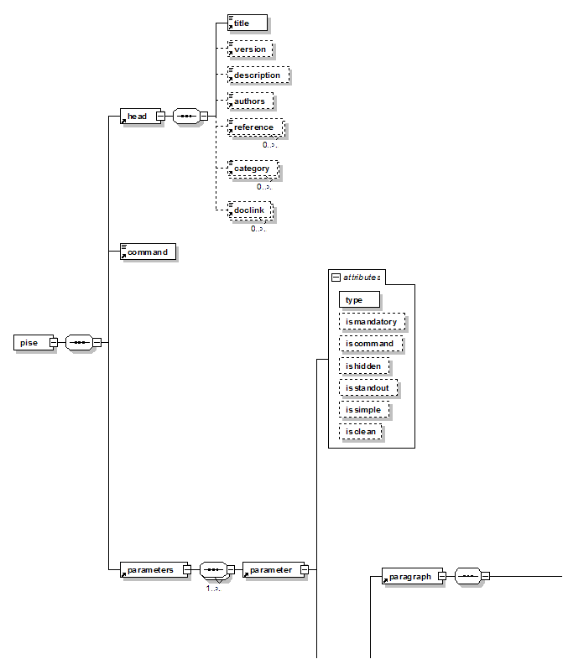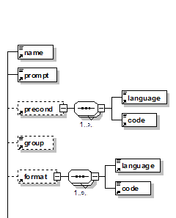
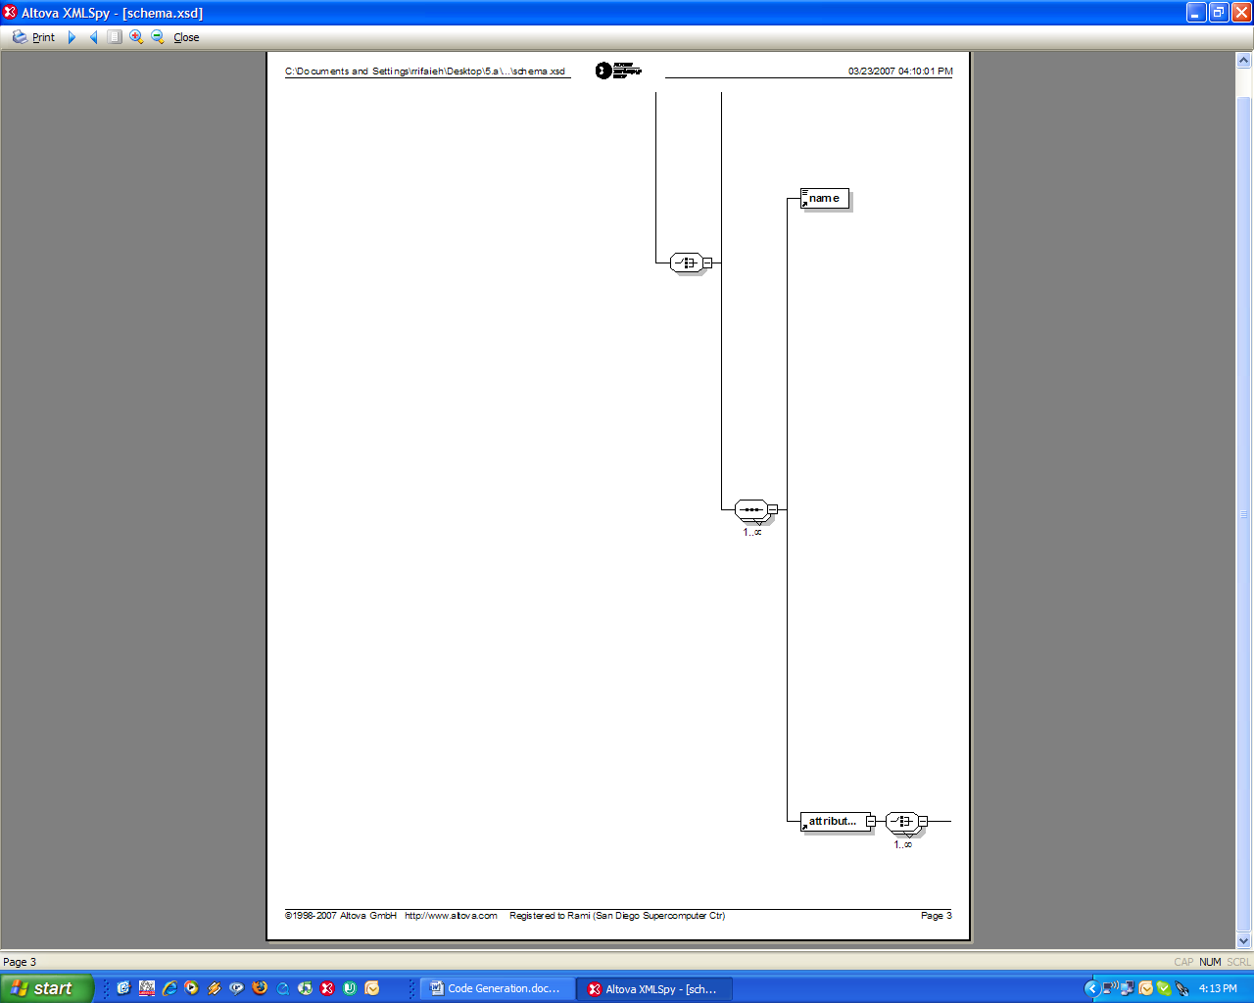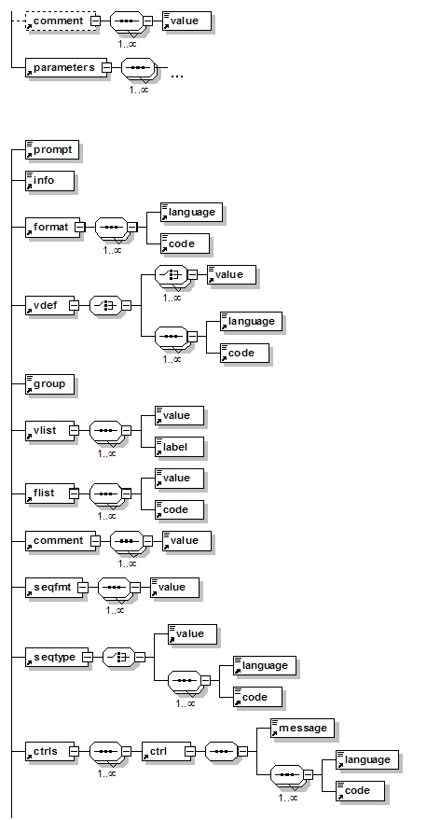
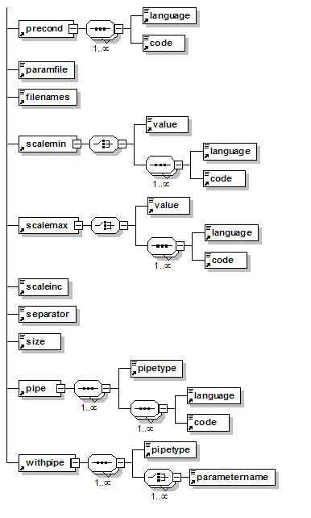

MOBYLE :
